Test Project Module 3
(Packaging)

Submitted by: Group 3

Ahmed Al-Harassi (OM)
Chun-Liang Lin (TW)
Anne Grandt (NO)
Vivian de Oliveira Preto (BR)
Sarah Jones (AU), Patricia Dupuis (FR)
Lars Ake Flodmark (SE)

Member Country: OM, TW, NO, BR, AU, FR, SE

Contents
This Test Project proposal consists of the following documentation/files:
Este proyecto esta basado en la siguiente documentacion/archivos:

• 1. WSC2013_TP40_MODX_PRE_EN.doc
• 2. WSC2013_TP40_MODX_PRE (folder)

Introduction
The company, “Teas of the World” manufactures traditional and herbal teas from different regions of the world. It selects the best teas from the most prestigious plantations. The “Teas of the World” company has been slowly perfected over time. They believe that tea, like wine — requires meticulous care in it’s brewing process and is a ritual. The brewing process of tea is said to be associated with love and friendship.

La Compania “Teas of the World” fabrica tradicionalmente Te de diferentes regiones del mundo. Selecionando los mejores Te de las mas prestigiosas plantaciones. La compania “Teas of the World” se esta perfeccionando con el correr del tiempo. Ellos creen que el Te, es como el vino, requiere de un meticuloso proceso a la hora de hacer un Te, como un ritual. El proceso de hacer Te esta asociado con el amor y la amistad .

The “Teas of the World” brand is over 300 years old and has a strong history associated with its company name. The brand has created a dynasty where successors inherit the talent of their elders and follow in their footsteps. Aesthetics, elegance and the pursuit of perfection are the aims of “Teas of the World”.

La marca “Teas of the World” tiene mas de 300 anos y tiene una historia muy fuerte asociada a su nombre . La marca fue creada como una dinastia donde los sucesores heredan el talento de sus antecesores y seguiran sus pasos. Estética, elegancia y perfeccion son los requisitos de “Teas of the World”.

“Teas of the World” are international leaders in the art of herbal teas. They offer products from all regions of the world, which links them to a culinary knowledge that enhances the taste while using their own basic principles and methodologies: “Teas of the World” embraces the art of brewing and enjoying tea and regards it as a "spiritual drink."

“ Teas of the World” es uno de los lideres internacionales del arte del Te de hiervas. Ellos ofrecen productos de todas las regiones del mundo, con el gusto ligado al conocimiento culinario, combinado con el gusto del Te en cuanto utilizan sus propios principios y tecnologia: “Teas of the World” abraza la idea de hacer Te y degustar el Te como una bebida espiritual.

“Teas of the World” has established itself over the years as being renowned as a sensual, cultural and joyful brand. They have succeeded with this through their combinations of cultural references, aesthetics and flavour combinations. The brand constantly looks toward the future for new innovations and creative tea blends, which they do in their laboratories and out in the tea-fields

“Teas of the World” tiene establecida por anos la idea de ser reconocida como sensual, cultural y alegre. Ellos quieren hacer de sus combinaciones fuertes referencias culturales, estéticas y combinaciones de sabores. La Marca procura constantemente innovar para el futuro los sabores/aromas creativos para los diferentes mezclas de Te, ellos hacen esto en los laboratorios y en los campos de Te.

To develop the brands range, the company “Teas of the World” want to market a new line of "sensorial tea products". They are aiming this tea at tea drinkers between the ages of 20-50 years all over the world that appreciate a healthy lifestyle as these teas are guaranteed to be 100% organic.

Para desarrollar una cantidad de sabores /aromas, la compania “Teas of the World”, quiere lanzar al mercado una nueva linea “sensorial tea products”. Ellos quieren penetrar en los consumidores este Te con edades comprendidas entre los 20-50 anos de todo el mundo y que aprecien un estilo de vida saludable ya que estos Te son 100% organicos.

Description of project and tasks
Descripcion del proyecto y tareas
You are required to create:

Usted debe realizar:

1. A logo for the “Sensorial Tea” line of products

1. Un Logo para la linea de productos “Sensorial Tea”

2. An outer cardboard package that contains the three tea varieties inside

2- Un empaque de carton que contenga tres variedades de Te dentro.

3. Three labels (stickers) — One for each of the tea varieties

3. Tres etiquetas (autoadhesivas) – Una para cada variedad de Te

Task 1: Logo Creation

Tarea 1: Creacion de Logo

You are required to create a logo for the tea range: “Sensorial Tea” (capital or lower-case according to your design). The name must be clear and readable. The proposed design should be adaptable to different blends of tea. You must use the text in Appendix 1.1

Debes crear un Logo para la Linea : “Sensorial Tea” (Puede ser en mayusculas y minusculas de acuerdo con su diseno). El nombre debe ser legible y claro. El diseno del logo debe adaptarse a los diferentes aromas/sabores del Te. Debes utilizar el texto del Apendice 1.1

Technical Specifications:
Especificaciones técnicas:

• Trapping: 0.1 mm (if necessary) Trapping: 0,1 mm (si es necesario)
• Printing: Offset Impresion: offset
• Native File format: EPS or AI Archivo original o nativo: EPS o AI
• File creation: Vector only Archivo solo vectorial
• Colours: Colores:
- One version in 2 x Pantone Uncoated Colours - una version en 2 X Pantone Uncouted Colores

- One version in CMYK Una version en CMYK

Electronic Files: Archivos electrónicos:

In a folder named Logo: Una carpeta llamada Logo:

• One native version of the Pantone logo Una version nativa de logo en pantone

• One PDF version of the Pantone logo Una version en PDF del logo en PANTONE

• One native version of the CMYK logo Una version nativa del logo en CMYK

• One PDF version of the CMYK logo Una version PDF del logo en CMYK

Printed Files: Impresion de archivos

• The Pantone logo and the CMYK logo will be printed on an A4 sheet side-by-side
(each logo to be no larger than 14cm in it’s largest dimension)

El logo en PANTONE y el logo en CMYK seran impresos en una hoja A4 lado a lado (cada logo debe tener máximo 14 cm en el lado mayor)

Task 2: Cardboard Package

Tarea 2: Empaque en carton

The design of the package should convey an ecological and natural feel. You must use at least two or more of the images provided in Appendix 2.3. You may manipulate the images according to your design. You may create any other elements not supplied. You must create a working die-line for the package, which will be large enough to contain the three supplied clear plastic bags of tea. You must use all text in Appendix 2.1 and all files in Appendix 2.2. Your die-cut should be fully functional and practical and indicate all glue, cut and fold lines.

El diseno del empaque debe trasmitir ser ecologico y natural. Usted debe utilizar minimo dos imagenes del apendice 2.3. Usted puede manipular las imagenes de acuerdo a su diseno. Usted puede crear otros elementos que no le son entregados. Usted debe crear una linea de troquel para el empaque que debe contener los tres saquitos de Te. Usted debe utilizar todo el texto del apendice 2.1 y todos los archivos del 2.2. Su troquel debe ser muy funcional y practico e indicar los puntos de pega, corte y dobles.

Technical specifications: Especificaciones técnicas

• Stock: Uncoated card 230gsm in SRA3 size Carton: Uncoated card 230gsm in SRA3 size

• Bleed (if necessary): 3 mm Sangria/bleed (si es necesário): 3mm

• Colours: CMYK + Die-line plate Colores: CMYK + troquel Die-line

• Image resolution: 250 - 300dpi placed at 100%

• Image resolution: 250 - 300dpi Exactamente al 100%

• ICC Profile for images: Perfil de ICC para las imagenes:

- CMYK: Uncoated FOGRA29 (ISO 12647-2:2004)

• Glue: You may use a maximum of 3 glue areas
Pegas: Usted puede usar no máximo 3 puntos de pega

• Window: Optional according to your design
Ventana: opcional de acuerdo como sea su diseno

• Ink Density: CMYK Maximum of 350%
Densidad de tinta: Maximo 350%

• PDF File Format: PDF/X-4:2008
Tipo de PDF: PDF/X-4:2008

• Native File format: INDD, EPS or AI
Arquivos originales/nativos: INDD, EPS o AI

• Raster images: tiff, psd or eps for raster images. Note: you MUST NOT embed the raster files

Imagenes rasterizadas: tiff, psd or eps for raster images. Usted NO DEBE embeber las imagenes rasterizadas

Packaging elements — All elements must be included in your package design:

Elementos del empaque – todos los elementos abajo deben estar incluídos en el diseno de su empaque:

• Logos to be included (These can be found in Appendix 2.2):

• Logos que debes incluir ( apendice 2.2)

- Teas of the world (to be used at least once in the design, but you may use it more than once)

- Teas of the World ( debe ser usado por lo menos 1 vez en el diseno, pero usted puede usarlo mas de una vez).

- Sensorial Tea (to be used at least once in the design, but you may use it more than once)

- Sensorial Tea ( debe ser usado por lo menos 1 vez en el diseno, pero usted puede usarlo mas de una vez).

- PEFC

- FSC

- Recycle

• EAN 13 bar code in 100% black and 30mm wide
Codigo de barras en 100% Negro y con 30 mm de ancho

• All Supplied text
Todo el texto entregado

• At least two of the provided images
Por lo menos dos de las imagenes entregadas

Electronic Files:
Archivos electrónicos

In a folder named Package: Dentro de una carpeta llamada Empaque

• 1 print ready PDF/X-4:2008 including ICC profile, die-line, bleed, colour bars and registration marks

1 archivo electrónico en PDF/X4:2008 incluyendo el Perfil ICC, linea de troquel, sangrado/bleed, código de barras, marcas de registro.

• All working files

Todos los archivos en que usted trabajo

Printed Files: Impresion de los archivos

• 1 colour printout cut and folded for presentation assembled in 3D (Printed at 100% on SRA3)

1 Impresion montada y cortada en 3D ( impresa en tamano real en 100% o SRA3)

• 1 colour printout mounted on the board provided (including the die-line) (Printed at 100% on SRA3)

1 impresion montada en un soporte entregado ( incluyendo linea de troquel) ( impresa em 100% o SRA3)

Task 3: Labels (Stickers)

Tarea 3: Labels (Stickers) - Etiquetas

The design of the three labels (stickers) should convey an ecological and natural feel. You must use at least one of the images provided on the label design from Appendix 2.3. You may manipulate the images according to your design. You must include the Sensorial Tea Logo and The Teas of the World Logo. You may create any other elements not supplied. You must create the die-line for the labels. You must use all text in Appendix 3.1

El diseno de tres (3) Etiquetas deben parecer ecologicas y naturales. Usted debe utilizar como minimo una imagen de acuerdo con su diseno. Usted debe incluir el logo de Sensorial Tea y el logo de Teas of the World. Usted puede crear otros elementos no entregados. Usted debe crear un troquel para las etiquetas . Usted debe utilizar todo el texto del Apendice 3.1.

Technical specifications: Especificaciones técnicas:

• Size: Each label must not exceed a maximum size of 50mm x 50mm plus bleed

Tamano: Cada etiqueta no debe exceder un tamano máximo de 50mm X 50mm incluye el sangrado.

• Stock: White uncoated sticker (adhesive) paper 150gsm in A4 size

papel: White uncoated sticker (adhesive) paper 150gsm en tamano A4

• Bleed (if necessary): 3 mm

Sangrado/bleed (si es necesário): 3mm

• Trapping (if necessary): 0.1 mm

Trapping (si es necessário): 0.1mm

• Colours: 2 x Pantone Uncoated Colour Logo + CMYK for all other elements + Die-line plate

Colores: 2 X colores Uncoated PANTONE del logo + CMYK para todos los otros elementos + troquel

• Die-line: may be the same shape or a different shape for each label

Troquel: Puede ser de la misma forma o una forma diferente para cada etiqueta

• Image resolution: 250 - 300dpi placed at 100%

• Resolucion de las imagenes: 250 - 300dpi colocadas a 100%

• ICC Profile for images: • Perfil de ICC de las imagenes:

- CMYK: Uncoated FOGRA29 (ISO 12647-2:2004)

• Ink Density: CMYK Maximum of 350%

• Densidad de tinta: Maximo de 350%

• PDF File Format: PDF/X-4:2008

• Tipo de PDF: PDF/x-4:2008

• Native File format: INDD, EPS or AI

• Formato nativo: INDD, EPS ou AI

• Raster images: tiff, psd or eps for raster images. Note: you MUST NOT embed the raster files

• Imagenes Raster: tiff, psd or eps para imagenes raster. Nota: NO DEBE embeber las imagenes raster

Label elements — All elements must be included in your label design:

Etiqueta – todos los elementos que se requieren deben de ser incluidos:

• Logos to be included: logos que deben ser incluidos

•Teas of the world logo for each label (supplied) (to be used at least once in each design, but you may use it more than once).

- Teas of the world para cada etiqueta (logo proporcionado) (debe ser usado por lo menos una vez en el diseno pero usted lo puede usar la veces que quiera)

• Sensorial Tea logo for each label (supplied) (to be used at least once in each design, but you may use it more than once).

• Sensorial Tea logo para cada etiqueta (logo proporcionado) (debe ser usado por lo menos una vez en el diseno pero usted lo puede usar la veces que quiera)

• All Supplied text as per Appendix 3.1 text file, one section of text for each label design

• Todo texto proporcionado en el apendice 3.1 archivo de texto, una seccion de texto para cada etiqueta disenada

Electronic Files: archivos electrónicos

In a folder named Labels: En una carpeta llamada Labels

• 3 Print ready PDF/X-4:2008 files including die-line, bleed, colour bars and registration marks (one for each design)

3 PDFs (PDF/X4:2008) una para cada etiqueta incluyendo en todas ellas, troquel, sangria/bleed, barras de colores y marcas de registro.

• 1 A4 PDF that displays all three designs on the one page

1 PDF que muestre todas las tres etiquetas juntas en una página A4

• All working files

Todos los archivos de trabajo

Printed Files: Archivos impresos

• 1 colour printout, cut and stuck onto the plastic bags for presentation and inserted into the 3D package
(All three designs printed on one A4 sheet)

1 impresion de las tres etiquetas que deben ser cortadas y colocadas en saquitos plásticos y colocadas dentro del empaque en 3D (Las tres etiquetas deben ser impresas en una hoja A4).

• 1 colour printout mounted on the board provided (including the die-line and all three designs with bleed
printed on one A4 sheet)

1 Impresion montada sobre un carton entregado (Incluyendo lineas de troquel de los tres disenos con sangria impresos en una hoja A4

When Printing: Cuando Imprimir

To avoid confusion between the candidates include your competitor number in the upper right corner of your print sheet

Para evitar confusiones entre los candidatos, incluya su numero de competidor en la esquina superior derecha de sus hojas impresas.

MARKING SCHEME

A. Creative process — Subjective /2
A.1 ideas and originality (package, logo & labels) 0.75
A.2 understanding the target market (package, logo & labels) 0.75
A.3 unity and relationship between all tasks (package, logo & labels) 0.50

B. Final design — Subjective /8
B.1 quality of the visual composition (package, logo & labels) 1.00
B.2 quality of the typography (package) 1.00
B.3 quality of the typography (logo & labels) 1.00
B.4 quality of the colours — choice, balance, harmony (package) 0.75
B.5 quality of the colours — choice, balance, harmony (logo & labels) 0.75
B.6 creativity of the package shape and labels 1.25
B.7 functionality and usability of the package shape 0.75
B.8 creativity of other design aspects — vector and raster elements 0.75
B.9 quality of the mounted presentation and the 3D assembly 0.75

C. Computer usage — Objective /4
C.1 resolution of images as specified in the task 0.50
C.2 image or element dimensions as specified in the task 0.50
C.3 final dimensions of layout as specified in the task (logo & labels) 0.50
C.4 all required and no additional text are present in the tasks 0.50
C.5 all required elements are present in the tasks 0.75
C.6 Ink density as specified in the tasks 0.50
C.7 die-line supplied as specified in the tasks 0.75

D. Manual abilities — Objective /2
D.1 mounting printouts on board for presentation 0.50
D.2 supply of printouts 0.50
D.3 assembling in 3d — package assembled and stickers applied 1.00

E. Knowledge of the printing industry — Objective /4
E.1 bleed value applied in pdf as specified in the task (package) 0.75
E.2 bleed value applied in pdf as specified in the task (labels) 0.50
E.3 printers marks supplied as specified in the task (labels and package) 0.50
E.4 trapping value applied in illustrator file as specified in the task (logo) 0.50
E.5 trapping value applied in illustrator file as specified in the task (labels) 0.75
E.6 spots and cmyk colours in pdf file as specified in the task 0.75
E.7 package design faces correct when assembled 0.25

F. Saving and file format — Objective /5
F.1 all files saved in the correct format specified in the task 0.75
F.2 icc profile applied in pdf as specified in the task (package) 1.00
F.3 icc profile applied in pdf as specified in the task (labels x 3) 0.75
F.4 saving in a specified pdf format as required in the task 1.50
F.5 final production folder saved as required in the task 1.00

Total = 25 marks per module (objective 15 + subjective 10)

OTHER

Appendix 1.1

Appendix_1.1.rtf:

Sensorial Tea

Appendix 2.1

Appendix_2.1.txt:

Best before date: 10.10.2015
Production date: 03.05.2013

The “Teas of the World” brand is over 300 years old and has a strong history associated with its company name. Our brand has created a dynasty where successors inherit the talent of their elders and follow in their footsteps. Aesthetics, elegance and the pursuit of perfection are our aims. Our blends expertly balance various teas and herbs with sweet flavours.
Welcome a weary stranger or transport you to the bustling alleyways all around world.

The Sensorial Tea range is an innovation in terms of taste and blend. These teas are guaranteed to be 100% organic.

Instructions
Rinse pot with boiling water to bring out the tea’s flavour. 1. Add loose tea according to your strength preference. 2. Add 3 teaspoons of sugar for a more traditional taste. 3. Pour in boiling water and leave for 2 – 3 mins. 4. Drink this tea without milk. 5. Stop what you are doing and savour the moment.
Use fresh water. Water left in the kettle loses vitality and makes the tea flavour not as vibrant.

PO BOX 432, OX90 9JK, England Tel: +44 (0) 2013 786 678 info@teasoftheworld.uk
Blended and packed in the UK.
We share your passion for fine teas and would love to hear any feedback or suggestions you may have.

3x30g

Meditation Tea
For calming and relaxing the body and mind
Lemongrass, Passionflower, Chamomile & Lavender

Uplifting Tea
For happiness and energising the spirit
Ginseng, Rooibos Tea, Blackcurrants, Goji Berries & Aloe Vera

Concentration Tea
For concentration and mental vigour
Green Tea, Basil, Blueberries, Rosemary & Chrysanthemum

Appendix 2.2

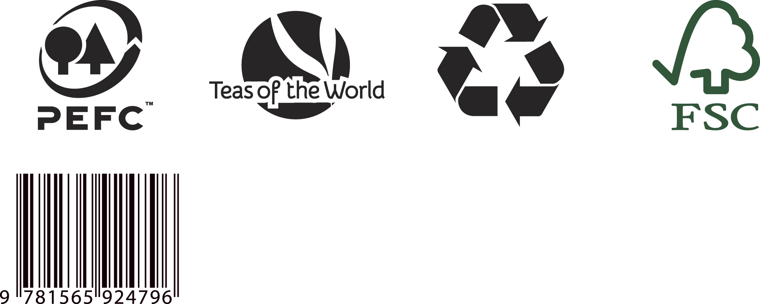

Appendix 2.3

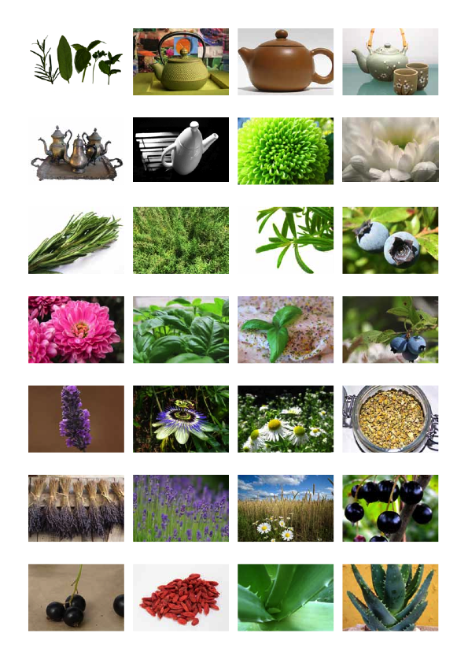
Appendix 2.3 (continued)

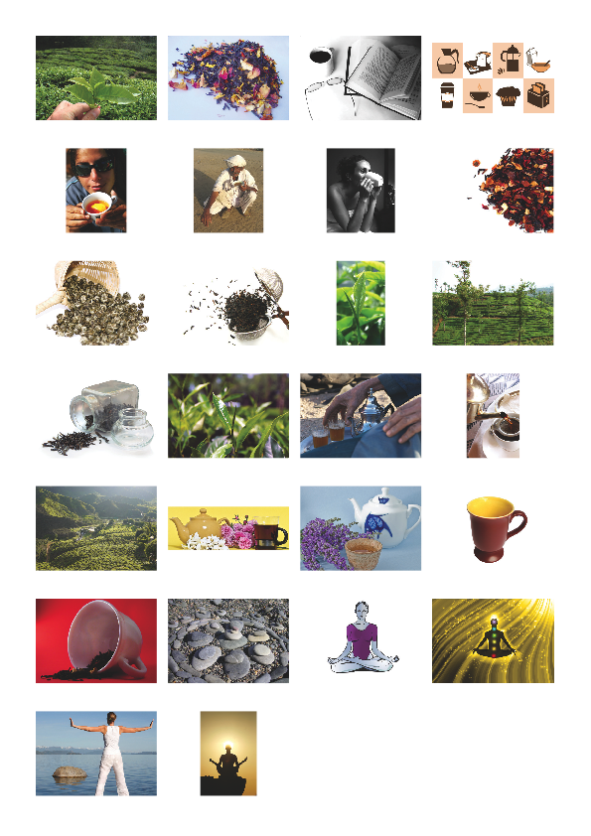

Appendix 3.1

Appendix_3.1.txt:

Label 1

Sensorial Tea Range: Teas to alter your body, mind and spirit

Meditation Tea
For calming and relaxing the body and mind
30g

Label 2

Sensorial Tea Range: Teas to alter your body, mind and spirit

Uplifting Tea
For happiness and energising the spirit
30g

Label 3

Sensorial Tea Range: Teas to alter your body, mind and spirit

Concentration Tea
For concentration and mental vigour
30g

